# 一、使用Dockerfile创建nginx

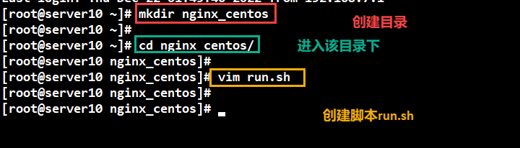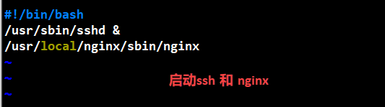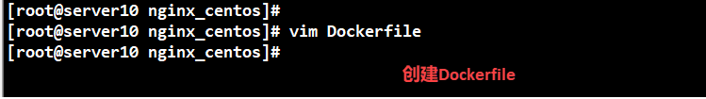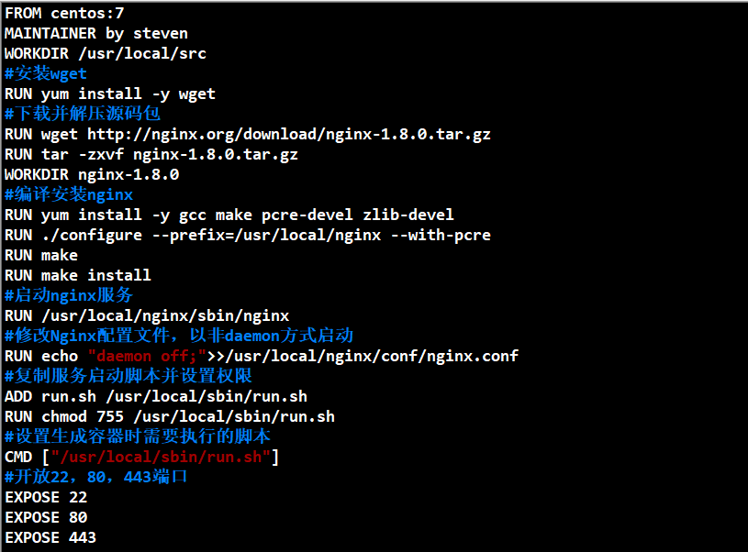

**FROM centos:7**

**MAINTAINER by steven**

**WORKDIR /usr/local/src**

**#安装wget**

**RUN yum install -y wget**

**#下载并解压源码包**

**RUN wget http://nginx.org/download/nginx-1.8.0.tar.gz**

**RUN tar -zxvf nginx-1.8.0.tar.gz**

**WORKDIR nginx-1.8.0**

**#编译安装nginx**

**RUN yum install -y gcc make pcre-devel zlib-devel**

**RUN ./configure --prefix=/usr/local/nginx --with-pcre**

**RUN make**

**RUN make install**

**#启动Nginx服务**

**RUN /usr/local/nginx/sbin/nginx**

**#修改Nginx配置文件,以非daemon方式启动**

**RUN echo "daemon off;">>/usr/local/nginx/conf/nginx.conf**

**#复制服务启动脚本并设置权限**

**ADD run.sh /usr/local/sbin/run.sh**

**RUN chmod 755 /usr/local/sbin/run.sh**

**#设置生成容器时需要执行的脚本**

**CMD ["/usr/local/sbin/run.sh"]**

**#开放22、80、443端口**

**EXPOSE 22**

**EXPOSE 80**

**EXPOSE 443**

# 二、使用Dockerfile创建tomcat9

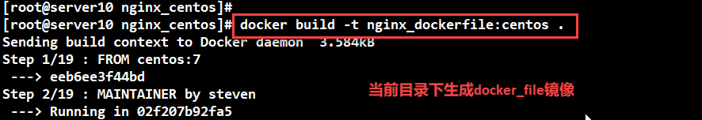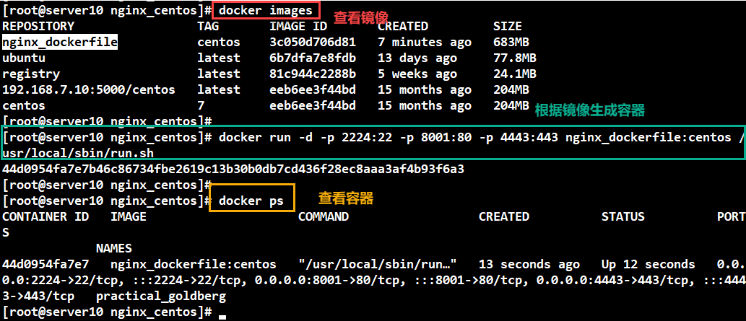

将容器的22端口、80端口和443端口分别映射到到宿主机上的2224端口、8001端口和4443端口,并运行服务脚本。

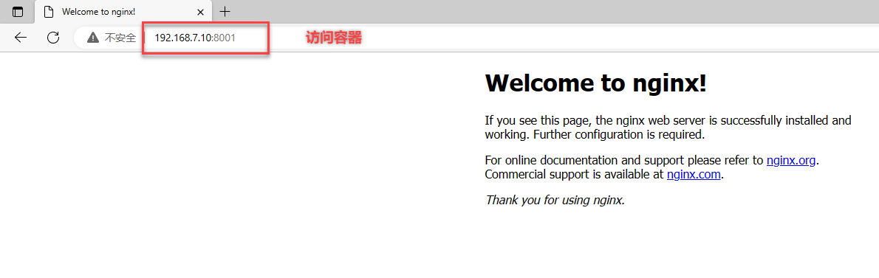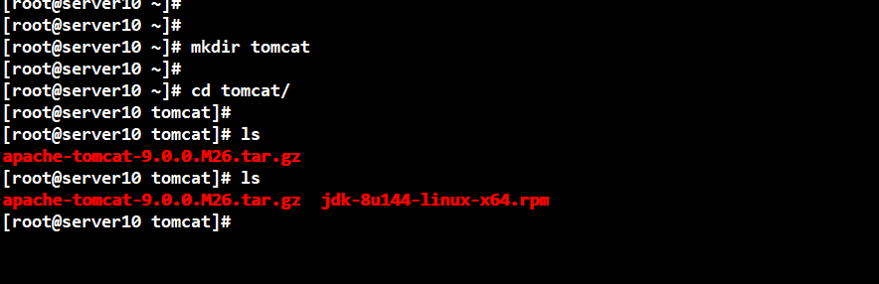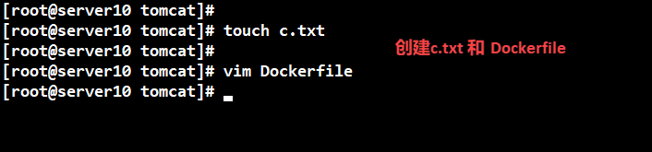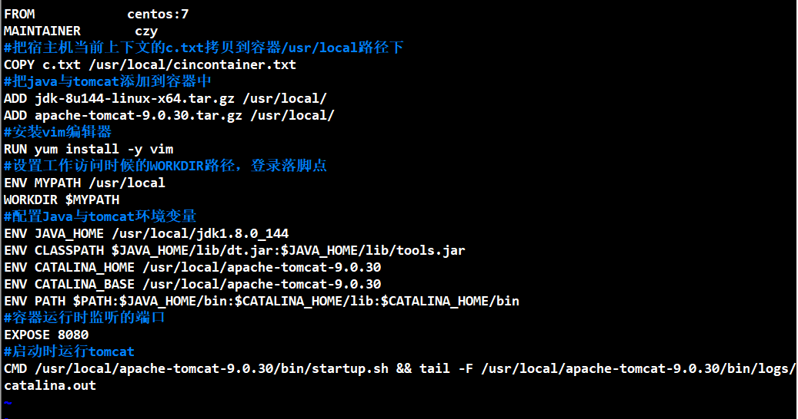

**FROM centos:7**

**MAINTAINER czy**

**#把宿主机当前上下文的c.txt拷贝到容器/usr/local/路径下**

**COPY c.txt /usr/local/cincontainer.txt**

**#把java与tomcat添加到容器中**

**ADD jdk-8u144-linux-x64.tar.gz /usr/local/**

**ADD apache-tomcat-9.0.30.tar.gz /usr/local/**

**#安装vim编辑器**

**RUN yum -y install vim**

**#设置工作访问时候的WORKDIR路径，登录落脚点**

**ENV MYPATH /usr/local**

**WORKDIR $MYPATH**

**#配置java与tomcat环境变量**

**ENV JAVA_HOME /usr/local/jdk1.8.0_144**

**ENV CLASSPATH $JAVA_HOME/lib/dt.jar:$JAVA_HOME/lib/tools.jar**

**ENV CATALINA_HOME /usr/local/apache-tomcat-9.0.30**

**ENV CATALINA_BASE /usr/local/apache-tomcat-9.0.30**

**ENV PATH $PATH:$JAVA_HOME/bin:$CATALINA_HOME/lib:$CATALINA_HOME/bin**

**#容器运行时监听的端口**

**EXPOSE 8080**

**#启动时运行tomcat**

**# ENTRYPOINT ["/usr/local/apache-tomcat-9.0.30/bin/startup.sh" ]**

**# CMD ["/usr/local/apache-tomcat-9.0.30/bin/catalina.sh","run"]**

**CMD /usr/local/apache-tomcat-9.0.30/bin/startup.sh && tail -F /usr/local/apache-tomcat-9.0.30/bin/logs/catalina.out**

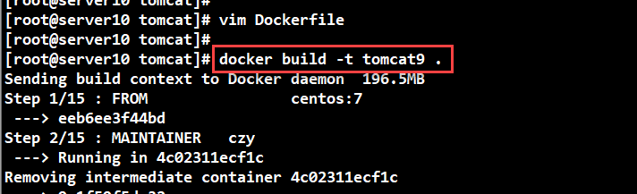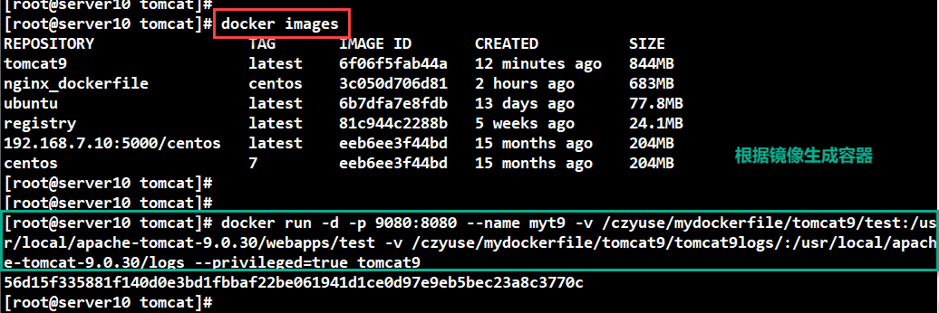

**docker run -d -p 9080:8080 --name myt9 -v /czyuse/mydockerfile/tomcat9/test:/usr/local/apache-tomcat-9.0.30/webapps/test -v /czyuse/mydockerfile/tomcat9/tomcat9logs/:/usr/local/apache-tomcat-9.0.30/logs --privileged=true tomcat9**

**注意：**

**docker kill 3dda2 //杀死容器**

**docker rm 3dda2 //删除容器**

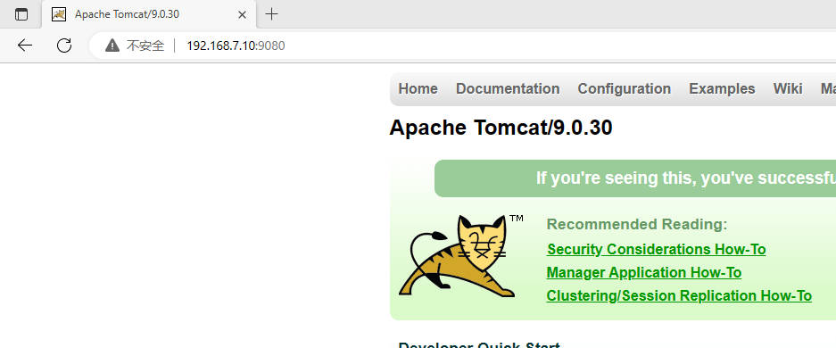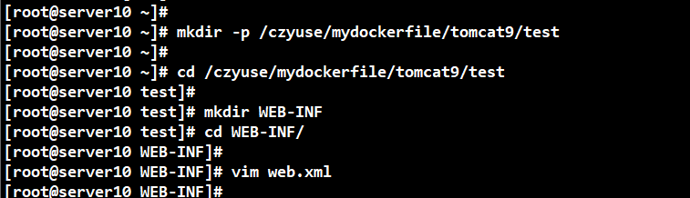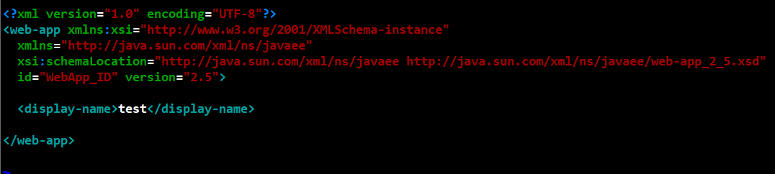

**<?xml version="1.0" encoding="UTF-8"?>**

**<web-app xmlns:xsi="http://www.w3.org/2001/XMLSchema-instance"**

**xmlns="http://java.sun.com/xml/ns/javaee"**

**xsi:schemaLocation="http://java.sun.com/xml/ns/javaee http://java.sun.com/xml/ns/javaee/web-app_2_5.xsd"**

**id="WebApp_ID" version="2.5">**

**<display-name>test</display-name>**

**</web-app>**

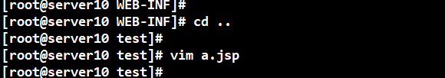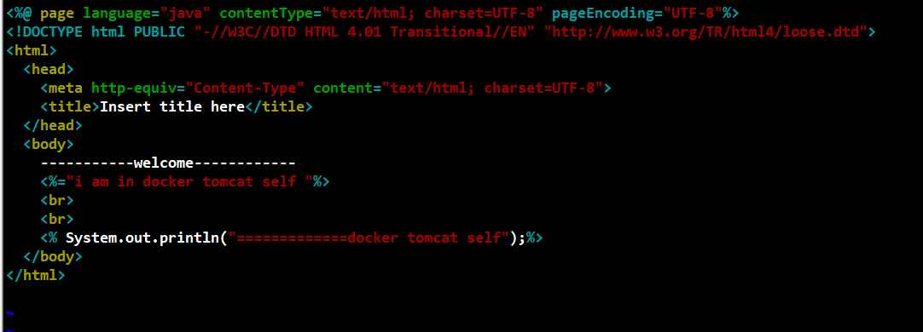

**<%@ page language="java" contentType="text/html; charset=UTF-8" pageEncoding="UTF-8"%>**

**<!DOCTYPE html PUBLIC "-//W3C//DTD HTML 4.01 Transitional//EN" "http://www.w3.org/TR/html4/loose.dtd">**

**<html>**

**<head>**

**<meta http-equiv="Content-Type" content="text/html; charset=UTF-8">**

**<title>Insert title here</title>**

**</head>**

**<body>**

**-----------welcome------------**

**<%="i am in docker tomcat self "%>**

**<br>**

**<br>**

**<% System.out.println("=============docker tomcat self");%>**

**</body>**

**</html>**

